AIM
Activity Supplier Invoice outbound
MD.120 deployment Instructions

Author: Motike Rahul Vardhan
Creation Date: March 24,2025
Last Updated:
Version: 1.0

Creating the OIC Integration for supplier Invoice Outbound

Creating the connection:
- First we need the create the connection for soap and ftp before creating the oic connection.
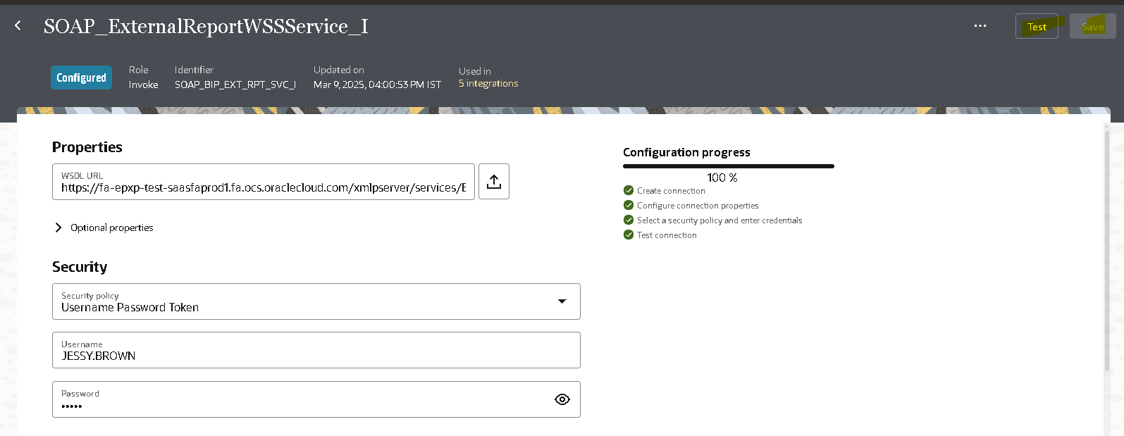
- Here we need to give the soap connection to the username,Url and password to it.
- Click on the test where if the configuration process is 100% then we can save it and use it for the connection.

- We need to create the ftp connection for it.

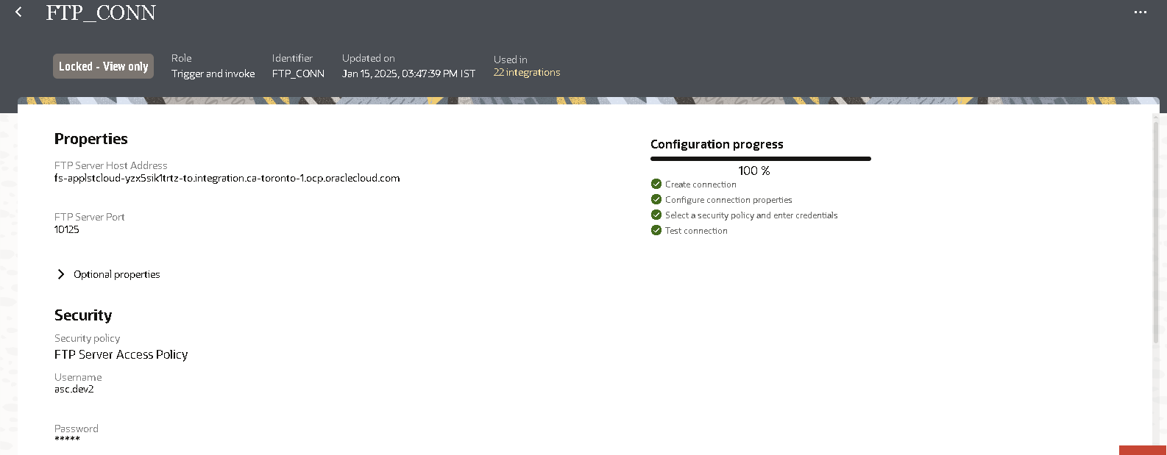
- Here we have given the ftp connection where we have configured the 100% by giving the username and password for it.

Creating the report for the supplier invoice :
- Firstly we need write a query to get the details of the supplier for it.
- Then we need to create the data model with the query in the oracle fusion instance.

- After creation of the data model then we need to create Report for it.
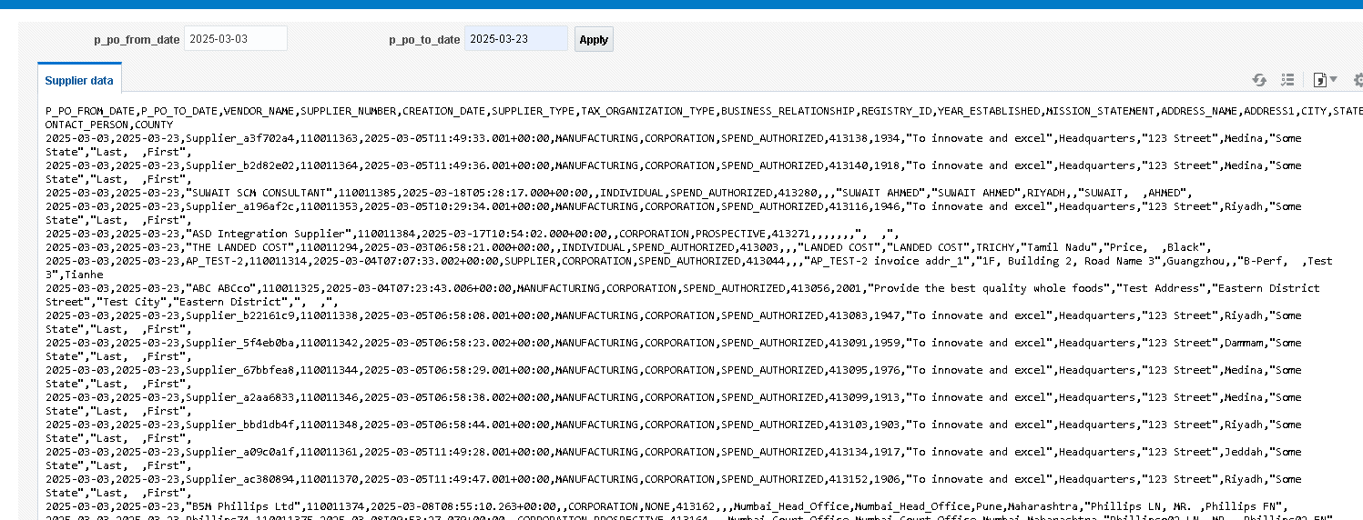

Developing the Schedule Integration:
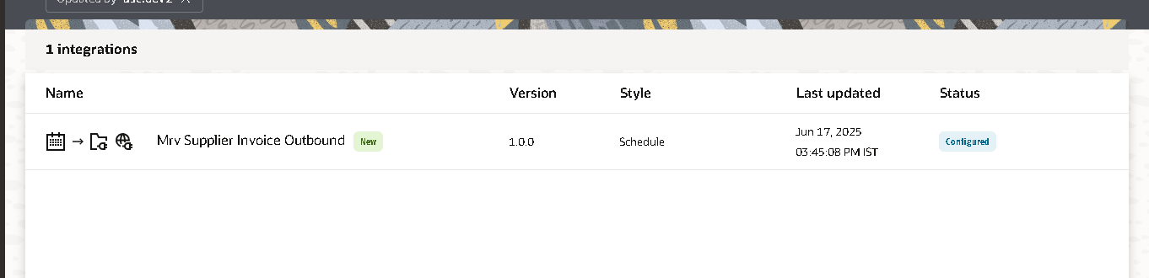
Go to the design and click on the create then select the schedule integration process.
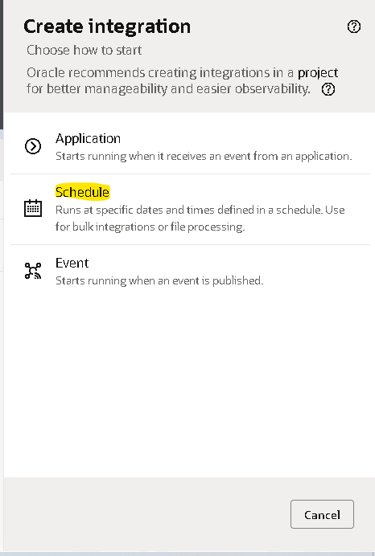
Here we can able to create the schedule integration for it.
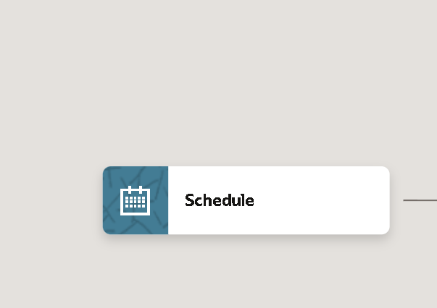
Then we need to assign the variables for it.
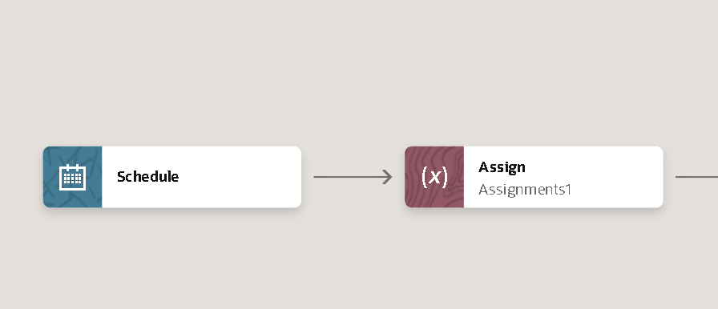
The variables are declared in the assign train.
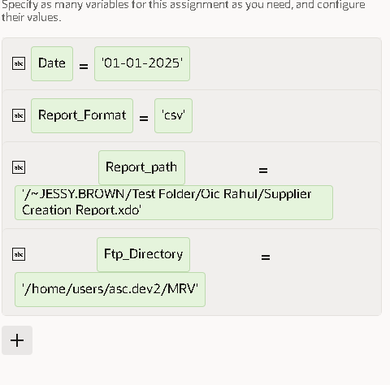
Report path : The path of the report in the oracle fusion.
The parameter consists of 2 parameters and from_date is given and to_date is taken from schedule date.
Report_format: the format is csv.
Ftp_directory: The directory of winscp(server) then we can able to delivery the csv in it.

Creating the soap connection:
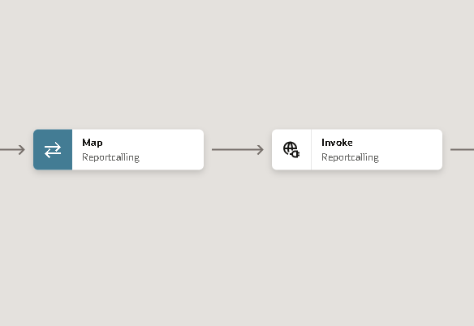
The connection for CallingtheReport to run report.
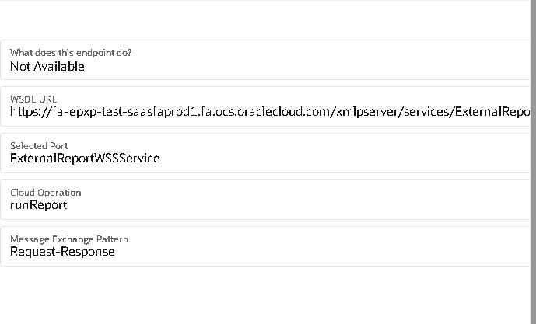
In the map we have assign the values to it.
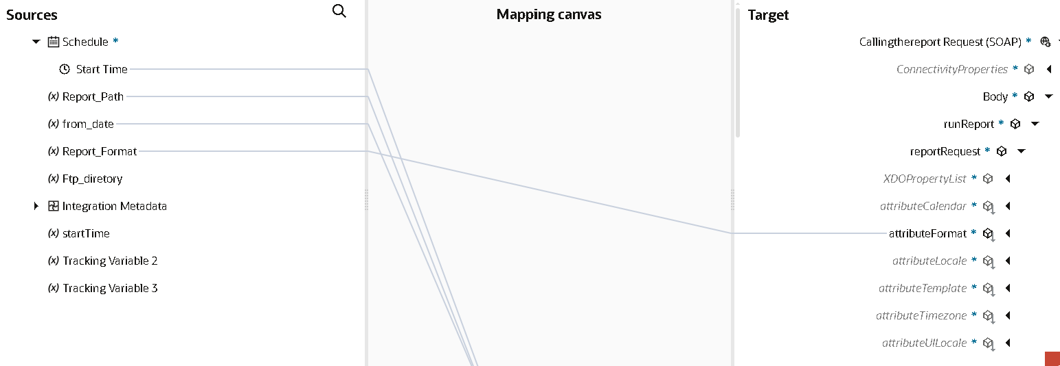

Creating the stage file to convert the format:
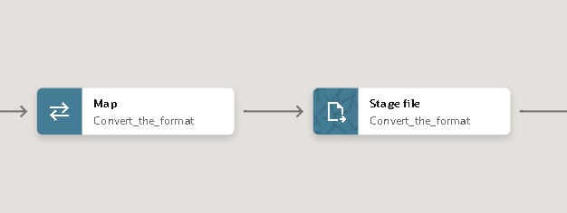
In the stage file we have created the write the file option.
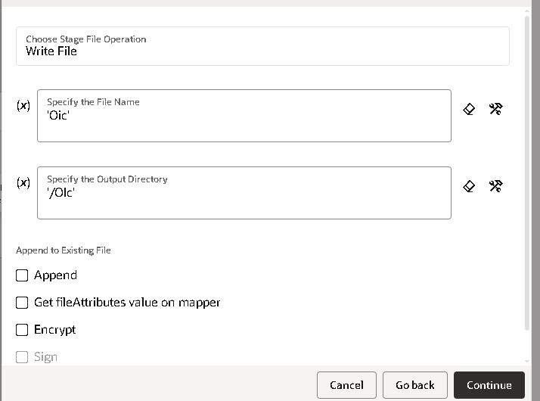
We have selected the xsd format for it.To get the file name.
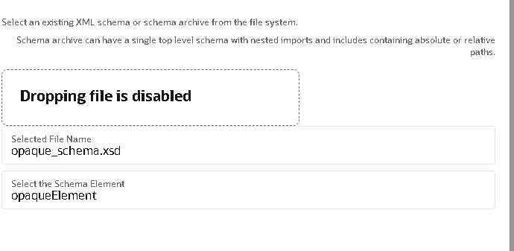
The xsd file uploaded in the file to get into it.
In the map we have mapped with the bytes to it.
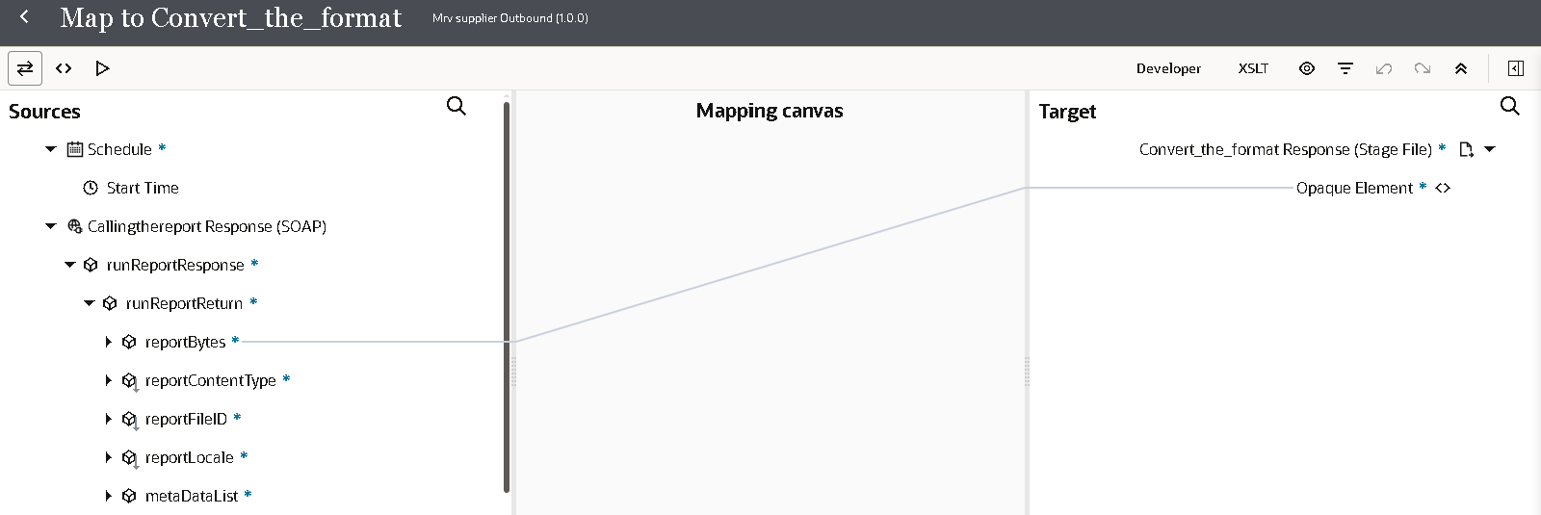

Creating the ftp connection for it:
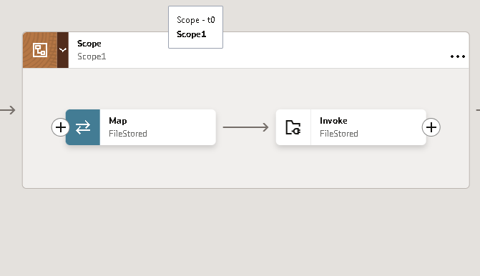
In the ftp connection I have selected the write file operation for it.
Then we need to give the output directory to save the file into it.
Then we have given the file reference to it and also the properties and output directory.
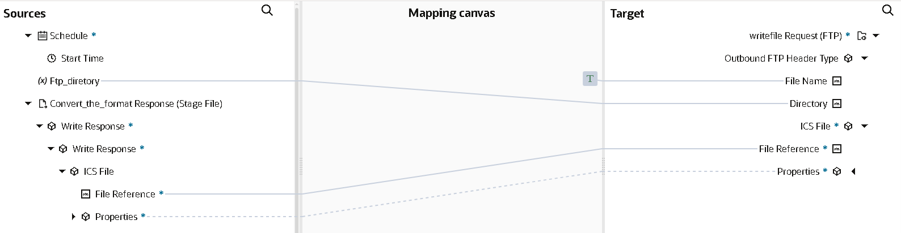
The overall integration of the supplier outbound integration:
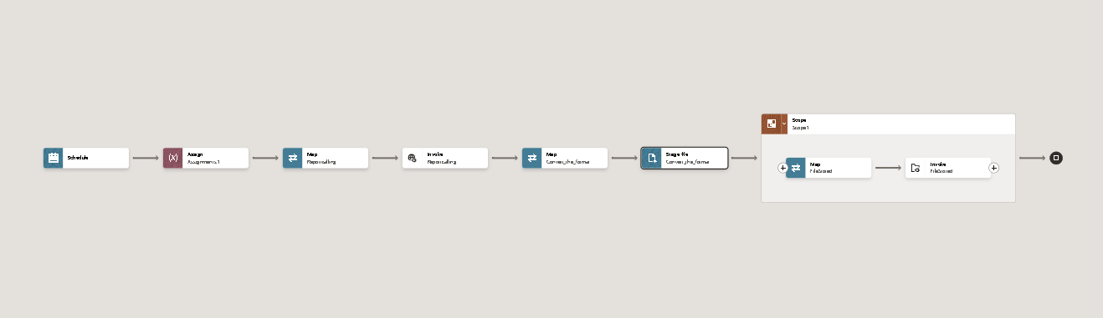

Click on the save and run the integration we can able to the get the file in the ftp server.

